**DAILY ONLINE ACTIVITIES SUMMARY**

|  |  |  |  |  |  |  |  |  |
| --- | --- | --- | --- | --- | --- | --- | --- | --- |
| **Date:** | **12-06-2020** | | | | | **Name:** | **Huda Sultana** | |
| **Sem & Sec** | **8 A** | | | | | **USN:** | **4AL16CS039** | |
| **Online Test Summary** | | | | | | | | |
| **Subject** | | **BDA** | | | | | | |
| **Max. Marks** | | **30** | | **Score** | | | **22** | |
| **Certification Course Summary** | | | | | | | | |
| **Course** | **Introduction to AWS CodeCommit** | | | | | | | |
| **Certificate Provider** | | | **AWS** | | **Duration** | | | **15mins** |
| **Coding Challenges** | | | | | | | | |
| **Problem Statement:**   1. **C program to Reverse a String using recursion.** | | | | | | | | |
| **Status: Solved** | | | | | | | | |
| **Uploaded the report in Github** | | | | | **Yes** | | | |
| **If yes Repository name** | | | | | **Hudasulltana/online_coding** | | | |
| **Uploaded the report in slack** | | | | | **Yes** | | | |

Online Test Details: (Attach the snapshot and briefly write the report for the same)

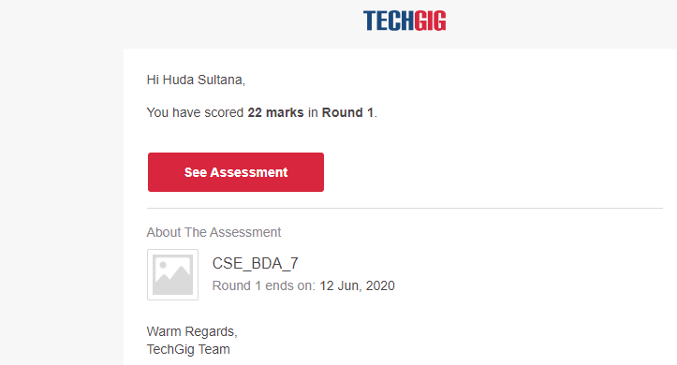

Certification Course Details: (Attach the snapshot and briefly write the report for the same)

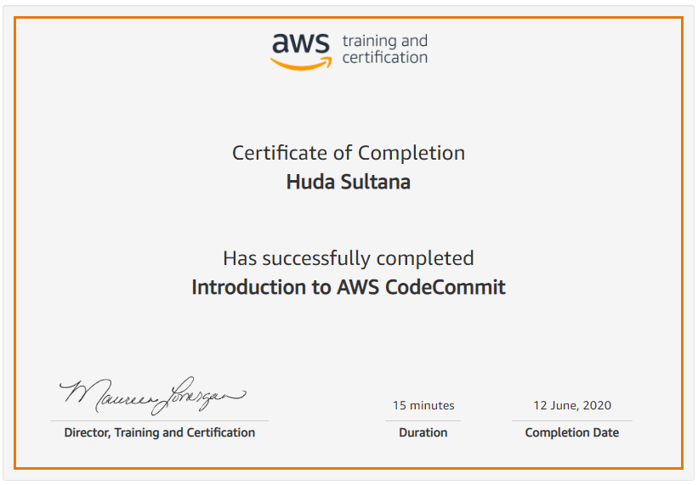

Coding Challenges Details: (Attach the snapshot and briefly write the report for the same)

**PROGRAM 1 .**

**//C program to Reverse a String using recursion**

**#include <stdio.h>**

**#include <string.h>**

**void reverse_string(char*, int, int);**

**int main()**

**{**

**char string_array[150];**

**printf("Enter any string:");**

**scanf("%s", &string_array);**

**reverse_string(string_array, 0, strlen(string_array)-1);**

**printf("\nReversed String is: %s",string_array);**

**return 0;**

**}**

**void reverse_string(char *x, int start, int end)**

**{**

**char ch;**

**if (start >= end)**

**return;**

**ch = *(x+start);**

**\*(x+start) = *(x+end);**

**\*(x+end) = ch;**

**reverse_string(x, ++start, --end);**

**}**